AppPoolRecycler

2018-12-03 joe.tretter@kcc.com

Summary
An intermittent issue keeps occurring:
The CAS Software would sometimes stop working – during that time many locks on the DB can be seen. Those locks will eventually bring the whole system to a halt. To resolve this problem, the Admin-team was asked to recycle the CAS Application Pool manually.
As the root cause of this issue could not be identified, I have implemented a Windows Service which automatically detects transactions that run for too long. If such transactions exist the corresponding Application Pool is recycled.
The Windows Service is called “AppPoolRecycler,” and it logs information into the Windows Event log.

Configuration
To enable non-standard Application Pool configurations and to fine-tune the recycling conditions configuration parameters can be modified in the config file “AppPoolRecycler.exe.config”:
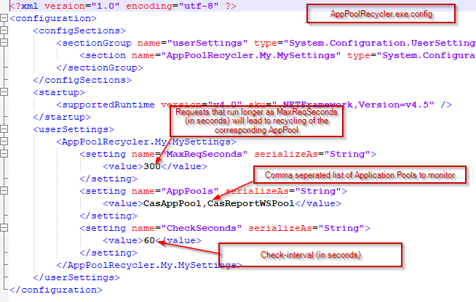
The design does not foresee to configure different recycling parameters by application pool.

Installation
The installation needs Admin rights, the “InstallUtil.exe” tool, which is part of the .Net framework is used to install- and uninstall services.
The AppPoolRecycler comes with two batch files which will install and uninstall the windows service. The batch file tries to determine that it is running with admin rights, and if so, will try to find the latest version of the installUtil.exe – it will then use this installUtil to install- or uninstall the windows service.
I recommend to install the AppPoolRecycler in the “Accenture” Folder:
Create a new Folder “AppPoolRecycler” under the “Accenture” Folder and copy the distribution files to this directory:
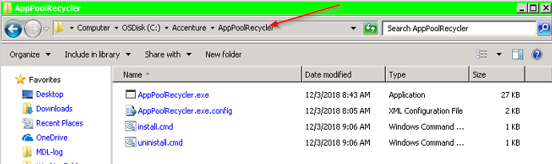

To install run the install.cmd as Administrator:
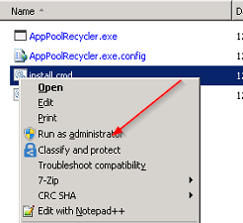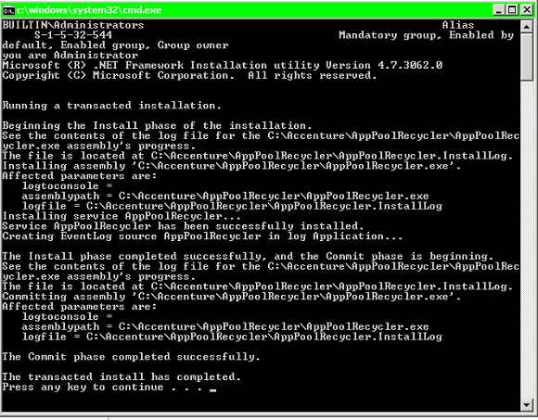
Start the service in the services:
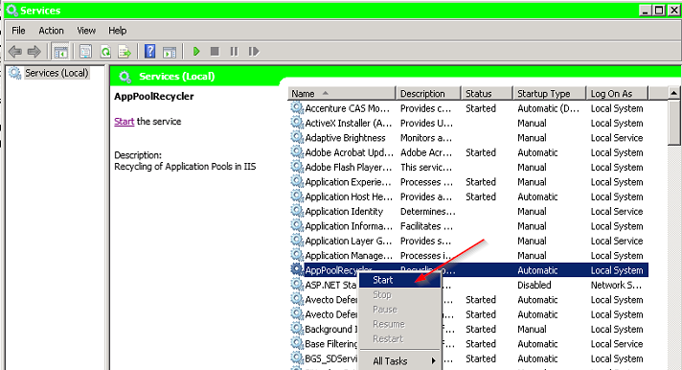

Monitoring
To monitor, watch the Windows Event log for messages with source “AppPoolRecycler”:
